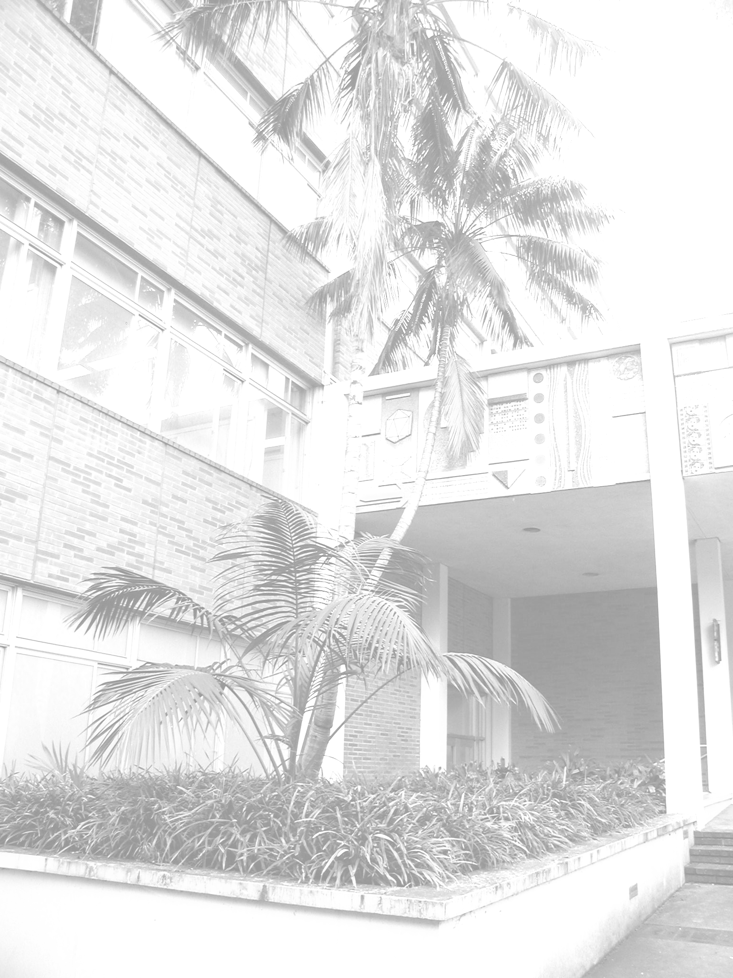

2013-2014 Distinguished Lecture Series

UCLA Department of Mathematics

Gilles Pisier



Lecture 1: Grothendieck’s inequality in the XXIst Century

Abstract: In a famous 1956 paper, Grothendieck proved a fundamental inequality involving the scalar products of sets of unit vectors in Hilbert space, for which the value of the best constant KG (called the Grothendieck constant) is still not known. Surprisingly, there has been recently a surge of interest on this inequality in Computer Science, Quantum physics and Operator Algebra Theory.
The talk will describe some of these recent developments

Lecture 2: The importance of being exact

Abstract: The notion of an exact operator space (generalizing Kirchberg's notion for C-algebras) will be discussed in connection with versions of Grothendieck's inequality in Operator Space Theory.

Lecture 3: Quantum expanders

Abstract: Quantum expanders will be discussed with several recent applications to Operator Space Theory. They can be related to “smooth" points on the Analogue of the Euclidean unit sphere when scalars are replaced by N × N-matrices. The exponential growth of quantum expanders generalizes a classical geometric fact on n-dimensional Hilbert space (corresponding to N = 1).
Lecture 1
Tuesday, October 22, 2013
3:00 - 3:50 pm
MS 6627

Lecture 2
Wednesday, October 23, 2013
3:00 - 3:50 pm
MS 6627

Lecture 3
Thursday, October 24, 2013
3:00 – 3:50 pm
MS 6627

The 2013 – 2014
Distinguished Lecture Series
is supported in part by the
Larry M. Weiner Mathematics Fund

Texas A & M University
Gilles Pisier
Texas A & M University

